`Problem D: Travel

Ideas:

**# Tanhim:**

**# Raad:**

1. GPS enabled system. Bus will be penalized if it stops without any bus stopage.

2. Bus route information. With rating for buses.

3. **Overtaking and lane change problem** solving: There will be laser sensors on every signal lights. Each sensor will sense vehicles in each lane. They will sense vehicle using height. Then they will sort the vehicle for the perfect lane it should stay. If it see that the vehicle is not in the right lane or if the vehicle is overtaking it will take a picture of the number plate. Later number plate will be used to charge. It can also solve **Illegal U-Turn** problems.

4. Create a ride sharing service too reduce unused spaces of private cars.

5. Sometimes there are incidents like Hartals, road construction, roab blocks.

We can introduce a feature to alert about these incidents. Users will create a route plan where he travel everyday/most of the days of the week. The user will get update on the night about any alerts of the routes.

**# Shakil:**

1. Implementing AR API to demonstrate traffic flow in real time around current position.
2. Use Google map API to map traffic flow in whole city. Traffic flow will be measured by footages captured by CCTV cameras deployed in different locations of the city.
3. Deployment of luxurious bus services like Dhakar Chaka will encourage more people to use public transport. They will be given smart cards which they will just punch and get in the bus. This will minimize the time spent in queue to almost zero. The bus will give passengers a notification 10 mins before its arrival which will be calculated based on the distance remaining and traffic flow aheadee.

**# Chisty:**

1. We can use  sensors to detect heavy traffic loads on the roads and also sensing the length of the traffic which gonna give us a proper idea about the entire traffic conditions.
2. This sensor will directly integrated with traffic signal which will control the flow of traffic where it needs and by using that the average traffic speed going to increase.

<https://www.youtube.com/watch?v=urWv-_EqS9M>

<http://airccse.org/journal/jcsit/6414ijcsit08.pdf>

* 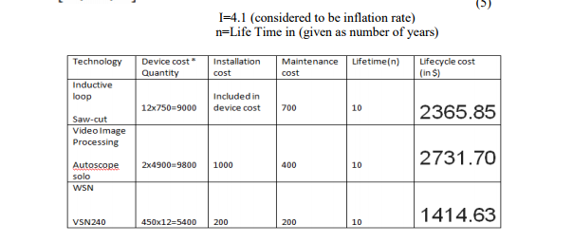

**Info to talk about in presentation:**

**the average person spends 60 hours in traffic each year (not for Bangladesh)**

**550 billion lost every year**

**3.2 million active hours lost every day**

**It is 50% more costly than it was in 2010**

[**http://en.prothom-alo.com/bangladesh/news/71961/Dhaka-s-traffic-congestion-costs-Tk-550bn-yearly**](http://en.prothom-alo.com/bangladesh/news/71961/Dhaka-s-traffic-congestion-costs-Tk-550bn-yearly)

* **Percentage of private cars and public transports of Dhaka city. [Find It]**
* **Average Life Expentancy of Bangladeshi is 72 years [World bank data]**

**https://www.google.com/publicdata/explore?ds=d5bncppjof8f9_&met_y=sp_dyn_le00_in&idim=country:BGD:IND:PAK&hl=en&dl=en**

**Average 1 hour wasted in traffic jam**

**26,280 hours in life wasted in traffic jam**

**1095 days in life wasted**

**3 years wasted**

* **UNDP estimated last year that time wasted in transport in the city was worth $4.6 billion of annual loss — this amount would be sufficient to build more than 30 kilometre of metro line every year.**
* **Only 8% of the city’s surface is covered with roads — the international standard is 25%  
    
  [Dhaka Tribune: http://www.dhakatribune.com/tribune-supplements/tribune-climate/2017/04/13/mitigating-traffic-congestion-remedies-dhaka-already-exist/]**
* **Even though there are 33 times more cars than buses in the city, cars account for just 13 percent of passenger transport, while buses are responsible for 49 percent.**
* **Some crowdsourced traffic apps had been developed in Bangladesh but they failed. Example: GoBD and Rastar Obosta app has rised for a few days but then failed and now are obslete. Why are they failing? How our solution is better than those traffic alert apps?**